**ENHANCED SOCIAL INTERACTIVITY LEVERAGED BY LOCAL PARTICIPANT DISCOVERY USING A CLOSE RANGE COMMUNICATION SYSTEM**

**ABSTRACT**

A method is described for enhancing social interactivity by discovering potential participants within a geographical locale using a close range communication system. Agents use a computer application, typically on a smart phone, to advertise identifying information to each other via a close range communication service, such as Bluetooth. A group of mutually identified agents can then form ad hoc communities of participants that interact in various social activities within the locale of the participants. Online interactions can be enhanced with the opportunity for personal interactions, leading to more satisfying social outcomes. Social activities might involve gaming, buying and selling, dating, and many more possibilities. Identities could also be authenticated, allowing trust-based transactions to take place.

**Inventors**:

Thomas E. Portegys, DeKalb, Illinois, USA ([portegys@gmail.com](mailto:portegys@gmail.com))

**CLAIMS**

**BACKGROUND OF THE INVENTION**

*FIELD OF THE INVENTION*

*DESCRIPTION OF THE RELATED ART*

*REFERENCES*

**SUMMARY OF THE DISCLOSURE**

**BRIEF DESCRIPTION OF THE DRAWINGS**

**DETAILED DESCRIPTION**

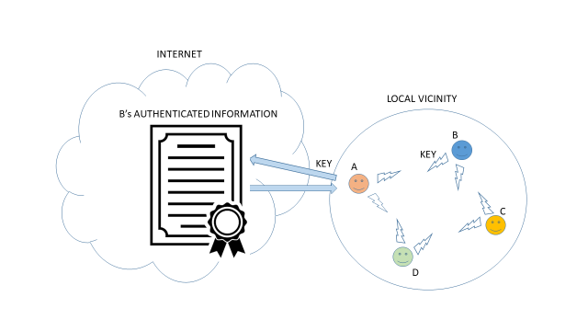

FIG. 1 – BASIC OPERATION